1.
Draw a labeled diagram of a typical home Wi-Fi setup showing a modem, router, switch, access point, and at least two devices (like a laptop and smartphone) connected to the network.
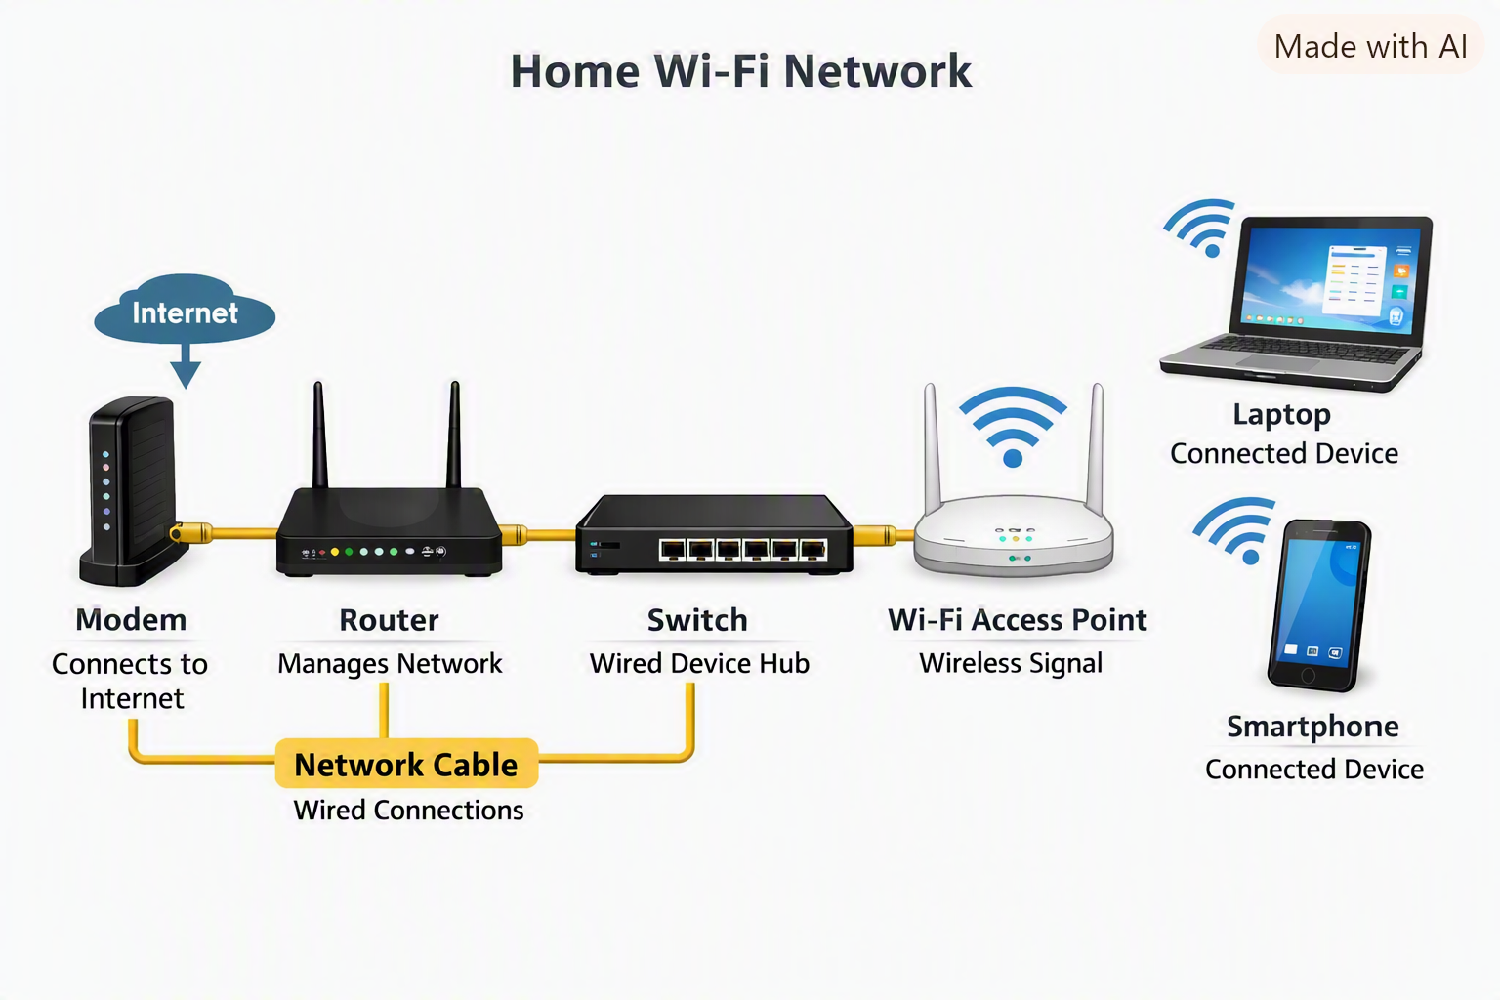

2.
List the main function of each networking hardware device: modem, router, switch, access point, and network cable. For each, give a real-life example of where you might see or use it (for example, 'router: at home to share internet').
Modem
- Function: Converts ISP signals (DSL, cable, fiber) into Ethernet for your network.
- Example: Cable modem at home to access internet via your ISP.
Router
- Function: Connects LAN to WAN, assigns IPs (DHCP), performs NAT, firewall.
- Example: Home Wi-Fi router that shares internet among family devices.
Switch
- Function: Expands wired connections, forwards data using MAC addresses.
- Example: Office LAN switch connecting PCs, printers, and servers.
Access Point (AP)
- Function: Provides Wi-Fi by bridging wired LAN to wireless devices.
- Example: Wi-Fi hotspot in a café or enterprise AP in a large office.
Network Cable
- Function: Physical medium carrying signals (Ethernet, coaxial, fiber).
- Example: Ethernet cable connecting a desktop PC to a router

3.
Take photos or find images online (with source links) of at least three types of network cables (such as Ethernet, coaxial, fiber optic) and write one line describing where each is commonly used.
Ethernet Cable (RJ45) – Commonly used in LANs to connect PCs, routers, and switches
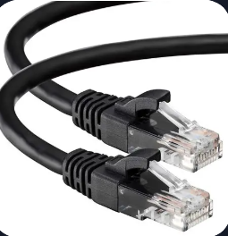

Coaxial Cable (RG-6) – Used for cable TV, broadband internet, and satellite connections
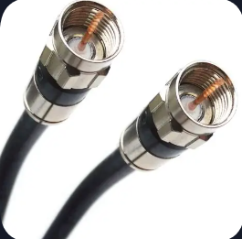

Fiber Optic Cable – Used for high-speed internet backbones and enterprise networks
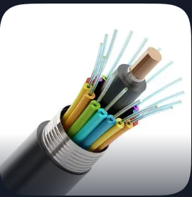

4.
Create a comparison table listing at least four differences between a router and a switch, including their main use, typical location, and how they handle data.
Feature | Router | Switch
OSI Layer | Layer 3 (Network) | Layer 2 (Data Link)
Address Used | IP address (IPv4/IPv6) | MAC address
Main Use | Connects LAN to WAN (Internet) | Connects devices within a LAN
Data Handling | Forwards packets between networks | Forwards frames within one network
Typical Location | At home/office edge, gateway device | Inside LAN for device interconnect

